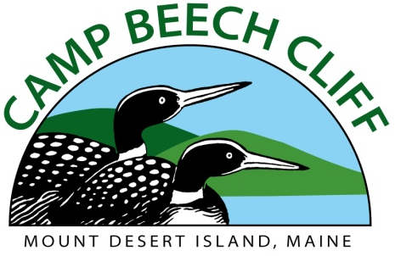

Program Director
Senior level administrative seasonal staff
Minimum qualifications: At least 23 Years old with enthusiasm for camp and youth, clear and honest communication skills, clean driving record, ability to supervise, BA Degree with significant camp experience preferred.
- Weekly salary range: $700 – $800 (DOE)
- Possible housing
- Commitment: Mid-May (depending on availability) through end of August.

Program Director responsibilities include (but not limited to):

- Immediate supervision and support of all day camp program head counselors and program areas (Archery, Arts & Crafts, Nature, Performing Arts, Sports & Games, Woodworking and Challenge Course, Swimming, and Boating)
- Coaching different teaching styles, conducting formal staff evaluations, tracking the program budget and program supply orders and improving the flow of camp;
- Assist in designing and leading staff training;
- Assist camp director in maintaining compliance with all Maine State Licensing and ACA accreditation standards
- Manage weekly program schedules Including daily camper choice activities and schedules of special all-camp programming
- Assist in planning and leading weekly in-service trainings as needed depending upon program
- Work with the administrative team to assist in the Counselor-In-Training (CIT) program;
- Act as a liaison between program staff and administration, conduct program staff meetings, and identify and assist with necessary continued staff training;
- Maintain positive professional relationships with all summer staff;
- Work as a member of the administrative team to maintain the quality of all camper (ages 5-15 yrs) experiences.

Considerations: Applicants should realize that the job of camp staff is challenging, demanding, and requires a great deal of patience and understanding. The Program Director, along with the Camp Director and Assistant Director, is one of the first to arrive at and last to leave camp each day. Personal lifestyle sacrifices will have to be made including disconnecting from daily use of digital technology during the camp day. Sensitive and dynamic leadership is necessary to provide youngsters the opportunity to grow, learn to positively relate to others, establish life-long values, and increase their appreciation of the natural world. All staff must adhere to the health and safety laws set forth by the State of Maine Dept of Human Services Youth Camps Division, and standards for accreditation with the American Camping Association. Possible Housing.

For more information or job application, visit www.campbeechcliff.org or contact matt@campbeechcliff.org. (ACA accredited Camp)

