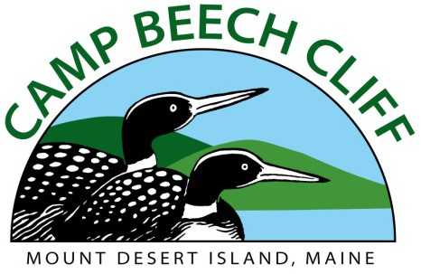
Program Head of Archery

Minimum qualifications:
- At least 20 years of age, and one year’s experience leading archery with children
- Hold at least a Level 1 Archery Instructor Certification (we can train)
- Enjoy working with children of all backgrounds
- Passionate about working outdoors
- Commit to June 5th through August 26th.
- Weekly Salary range: $600-$700
- Possible Housing

Program Head Counselor of Archey duties include (But not limited to):
- Ability and creativity to plan a wide range of Archery related activities and programs throughout the summer
- Build Developmentally Appropriate programming for campers aged 5 – 15 with physical lesson plans as needed
- Manage a Small Program Area Budget
  - Identify supply needs
  - Submit supply orders in a timely fashion
- Communicate goals and expectations to all campers and staff who enter the Archery range
- Delegate tasks and responsibilities to group counselors as needed at the archery range
- Maintain a safe and clean space for all campers and staff
- Work with Program Director and other Program Head Counselors to plan weekly “All-Camp” activities known as Fracky Fridays
- Supervise Archery Program Instructor (assists in operations and programming at the range)

Considerations: Applicants should realize that the job of a camp counselor is challenging, demanding, and requires a great deal of patience and understanding. Personal lifestyle sacrifices may have to be made including disconnecting from daily use of digital technology during the camp day. Sensitive and dynamic leadership is necessary to provide youngsters the opportunity to grow, learn to positively relate to others, establish life-long values, and increase their appreciation of the natural world. Salary depends on level of experience and relevant certifications ($600 - $700 per week). Possible housing available.

Preferred qualifications: Bachelor’s Degree and at least two years of direct experience in teaching archery to kids. If no degree, equivalent work experience preferred.

For questions and to submit application: www.campbeechcliff.org
Matt Cornish, Camp Director matt@campbeechcliff.org

264 BEECH HILL ROAD PO BOX 381 MOUNT DESERT, MAINE 04660 P. 207-244-0365 F. 207-244-3355 WWW.CAMPBEECHCLIFF.ORG

